Quartus II – Fitter (Place & Route) Error – Bus-Hold Circuitry

**Conditions/Situation**

The error seems to be cause by including custom Avalon_PWM module, which uses buffers, with bus-hold circuitry for output pins.

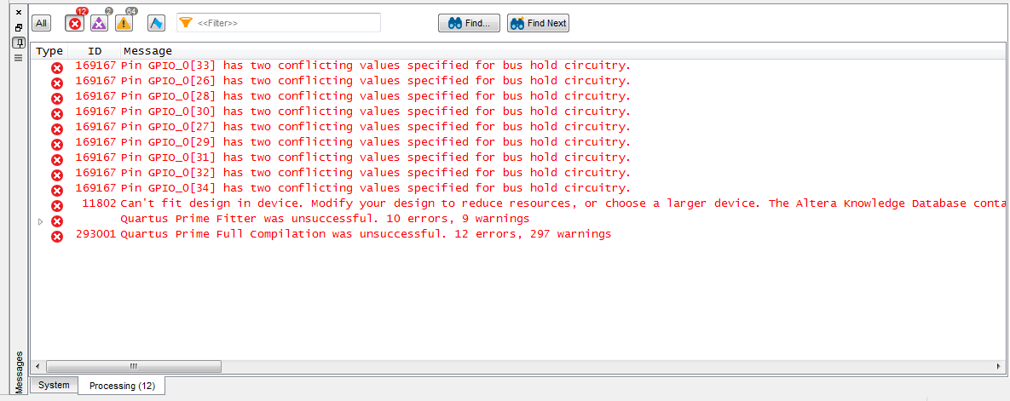

Snapshot from Quartus II after failed compilation.

**How to**

Enabling the bus-hold circuitry for specified pins resolves the issue. This is done using Pin Planner as shown below.

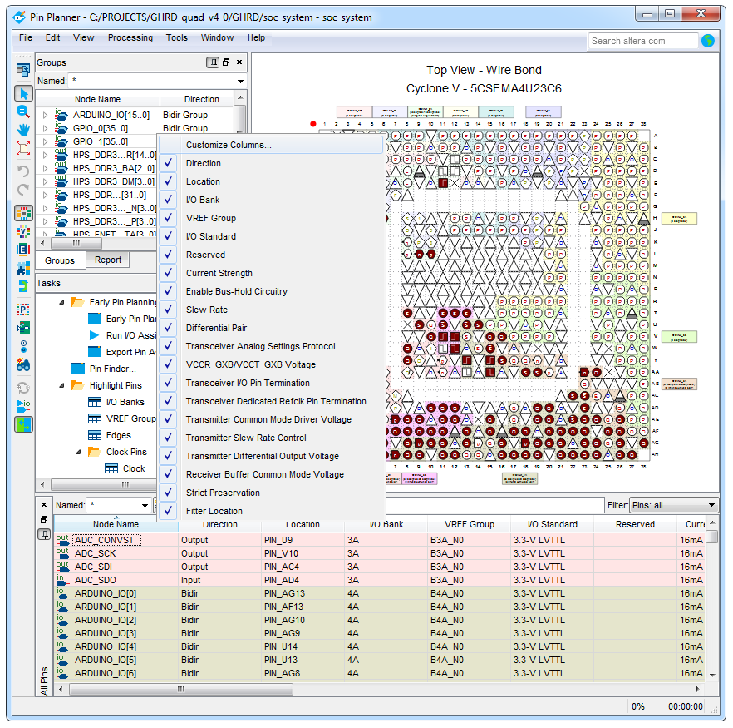

The “Enable Bus-Hold Circuitry” column, doesn’t need to be present in default settings of Pin Planner. To make the column visible, follow :

1. Right-click the attribute bar and select Customize Columns
2. Choose “Enable Bus-Hold Circuitry” and using right-arrow button move it to the right column, according to the figure below.

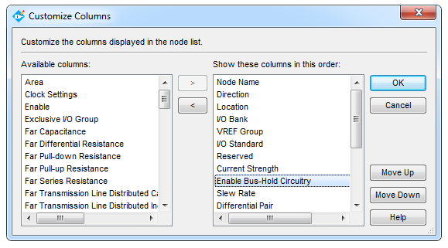

Disable Bus-Hold Circuitry for all conflicting pins. Back up the ghrd.v top file design in Quartus II, because updating the Pin Planner changes wipes the ghrd.v.

Pin Planner -> File -> Create/Update -> Create Top-Level Design File …

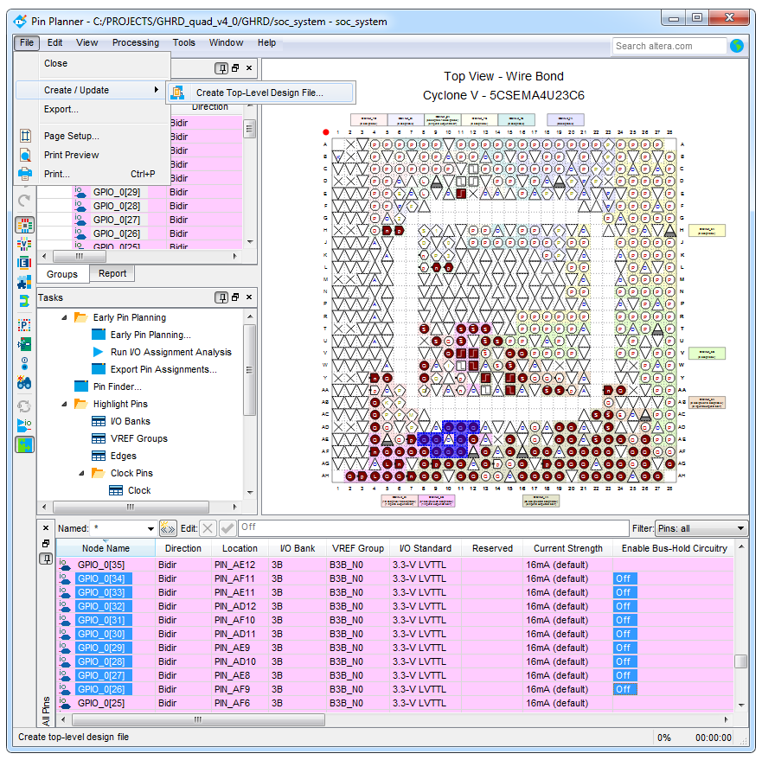

Rewrite the ghrd.v file with the back-up, re-run the Quartus II compilation process.

